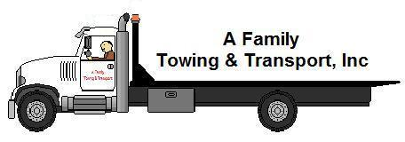

AVAILABLE CALL US AT
24 HOURS (630) 336-4436
EVERY DAY FOR ALL YOUR
OF THE YEAR TOWING NEEDS!

VISIT OUR WEBSITE AT afamilytowingandtransport.yolasite.com
**************************************************************************************************
TOWING AND ROAD SERVICE RATES
TOWING FLAT RATE
FLATBED $65.00
WHEEL-LIFT $60.00
VANS $75.00
TOOL BOX $85.00
EQUIPMENT (Pallets, etc.) $90.00

ROAD SERVICE
JUMP START $40.00
FLAT TIRE CHANGE $50.00
FUEL DELIVERY (plus mileage) $30.00

MILEAGE RATE
CARS $2.25/mile
VANS $3.00/mile
***********************FLAT RATE INCLUDES 5 FREE MILES********************************

CANCEL JOB UPON ARRIVAL
CANCELLATION FEE $25.00

**************************************************************************************************
ANY TOWING OR ROAD SERVICE BETWEEN 10PM & 7AM OR ON HOLIDAYS (Additional) $30.00
**************************************************************************************************

***PRICES ARE SUBJECT TO CHANGE***

